Steps to Perform a Mail Merge (RTF Format)

1) Prepare your letter using Microsoft word (NOTE: You must start your field to <FIELD4> then <FIELD5>, <FIELD6> so on….)

The programmer already hard code in the system that FIELD4 corresponds to FIELD1

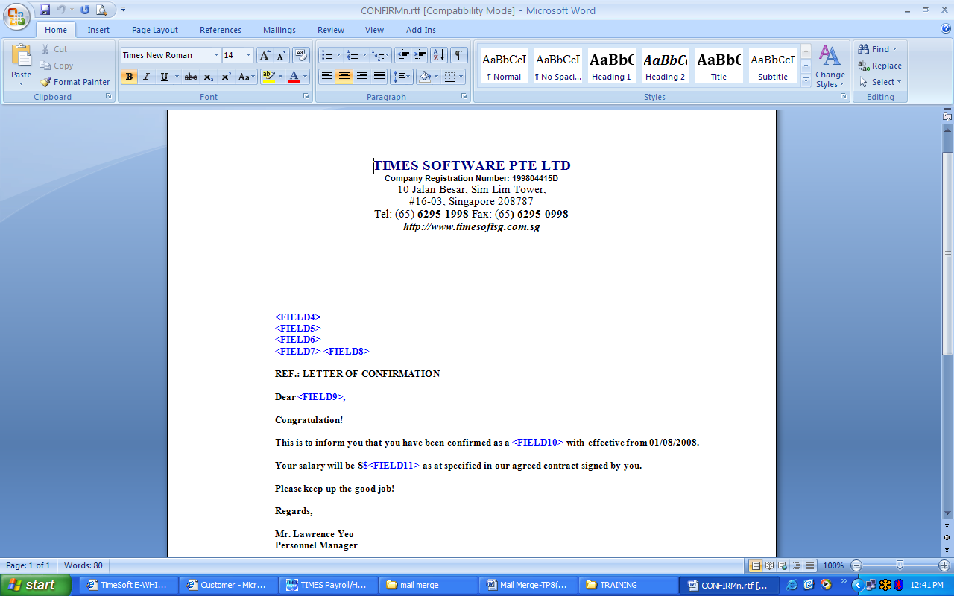

After you key in everything you must save the file as Rich Text Format (*.rtf) type.

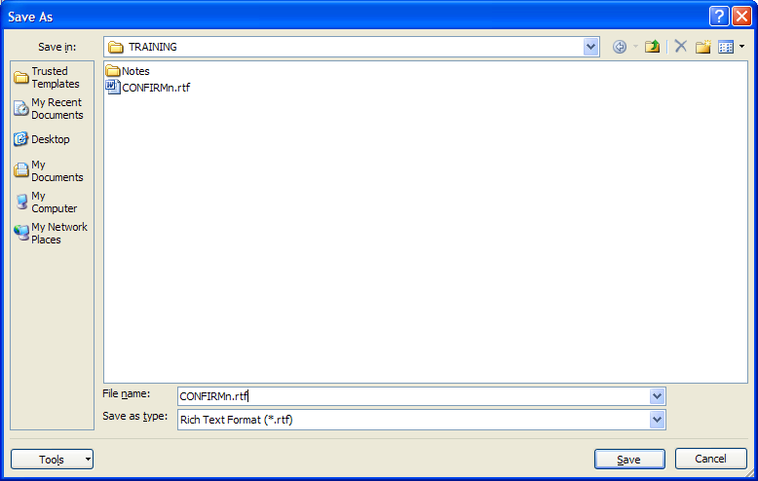

2. After you create the letter, you must login on TimesPay8. At the Report Writer ---Report Generator, you are required to create a new report.

To create the report using Report Writer please go to Report Writer --- Report Generator

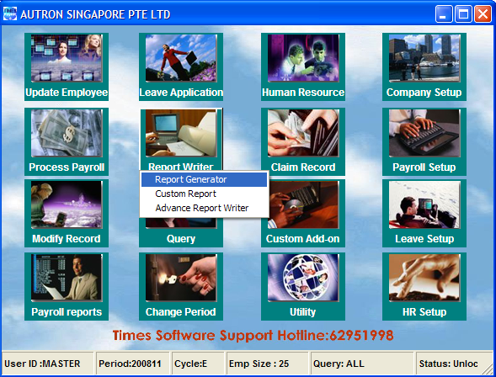

Click the New button

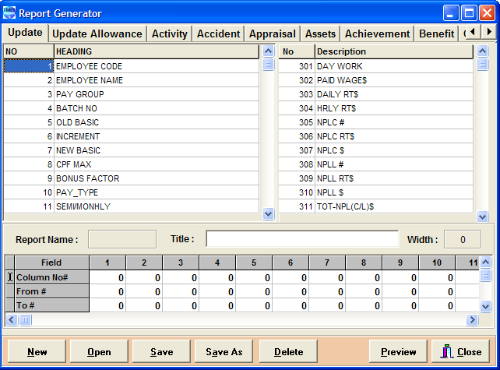

Key in the Report Name, Report Title and Report Type – for the report type choose Tabular.

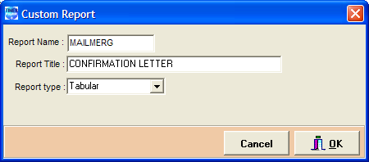

Insert the respective fields accordingly (refer to the letter - CONFIRM.rtf) and saved the report. (Column 1 = Field4, Column 2 = Field5 etc).

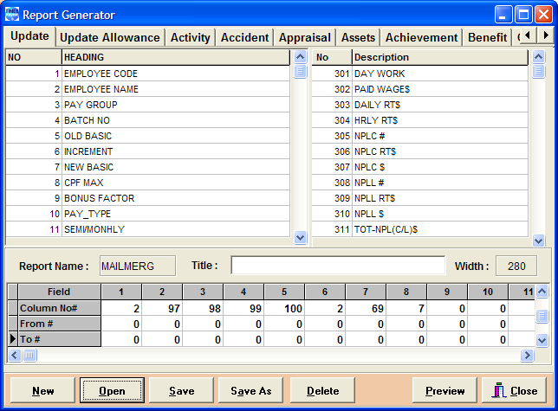

2 - Employee Name
97 - Address1
98 - Address2
99 - Address3
100 - Postal
2 - Employee Name
69 - Occupation Desc
7 - New Basic
3) At Payroll Reports --- Mail Merge, you are required to select the appropriate

Report Name (the name of the report you created on the Report Writer), Query (if you don’t want to call ALL the employee you can use the Query to select those employee you want to generate. Please choose the Query that you have created) Merge File (browse the path where you save the letter). After that click the Preview button

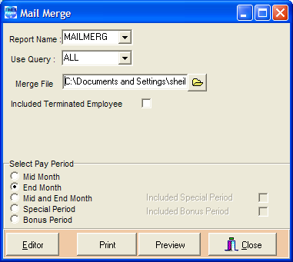

Click the folder button to browse the file.

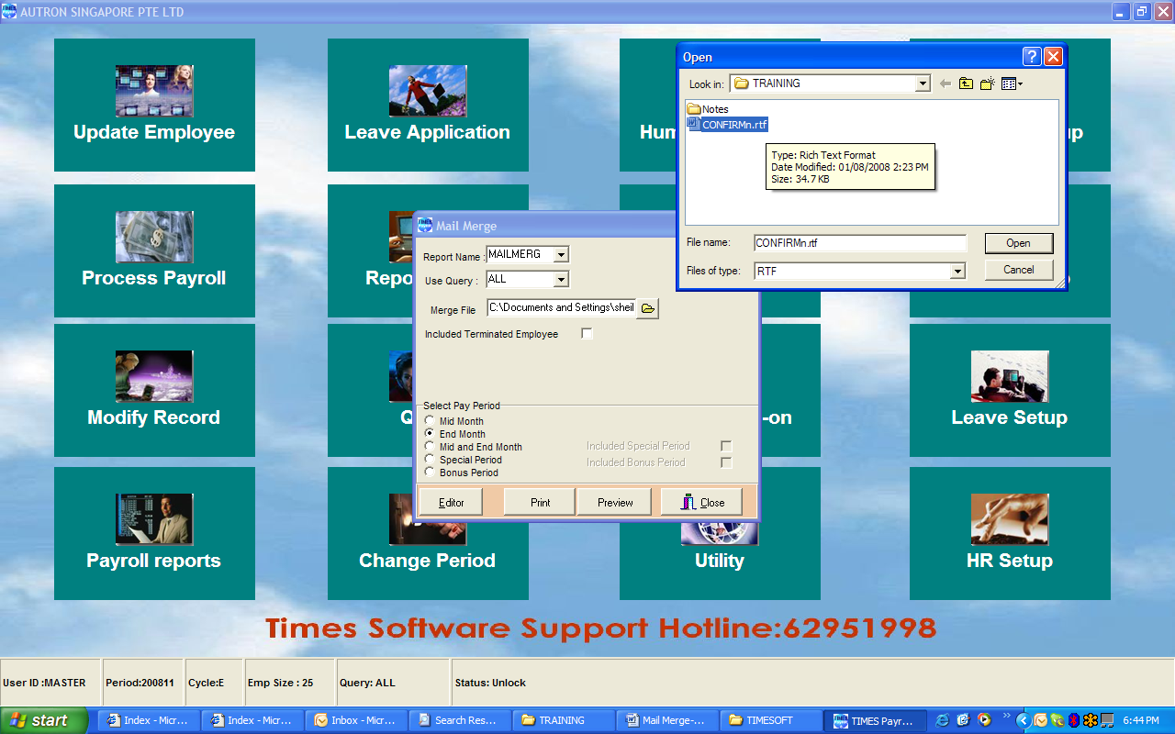

Select Preview
After that please click the Preview button

4) Finally, you should see the documents/appraisal as requested.

