E-Casual for Windows 98/NT/2000/XP/2003
(.net Version)



TIMES SOFTWARE PTE LTD
Company Registration Number: 199804415D
10 Jalan Besar #14-01 Sim Lim Tower
Singapore 208787
Tel: (65) 6295-1998 Fax: (65) 6295-0998
http://www.timesoftsg.com.sg

Contents | Page
Administrator’s Guide for E-Casual Labor System ---------------------- | 3
Step 1: Logging into the E-Casual Labor as Administrator | 3
Step 2: Setting Rate | 3
Step 3: Access Code Setup | 5
Step 4: Dept / PCard Setup | 6
Step 5: Code Setup | 7
Administrator’s Guide for Casual Labor System ------------------------- | 8
How to Key in Employee Master | 8
Casual Labor Allowance Mapping setup | 13

Administrator Training Guide for E-Casual Labor System

Step 1: Login to E-Casual Labor as Administrator
1.1 For the administrator Login page
Login ID: admin
Password: -

Step 2: Rate Setup
(Setting pay rate for Internal Staff, External Staff, and Agency Staff)
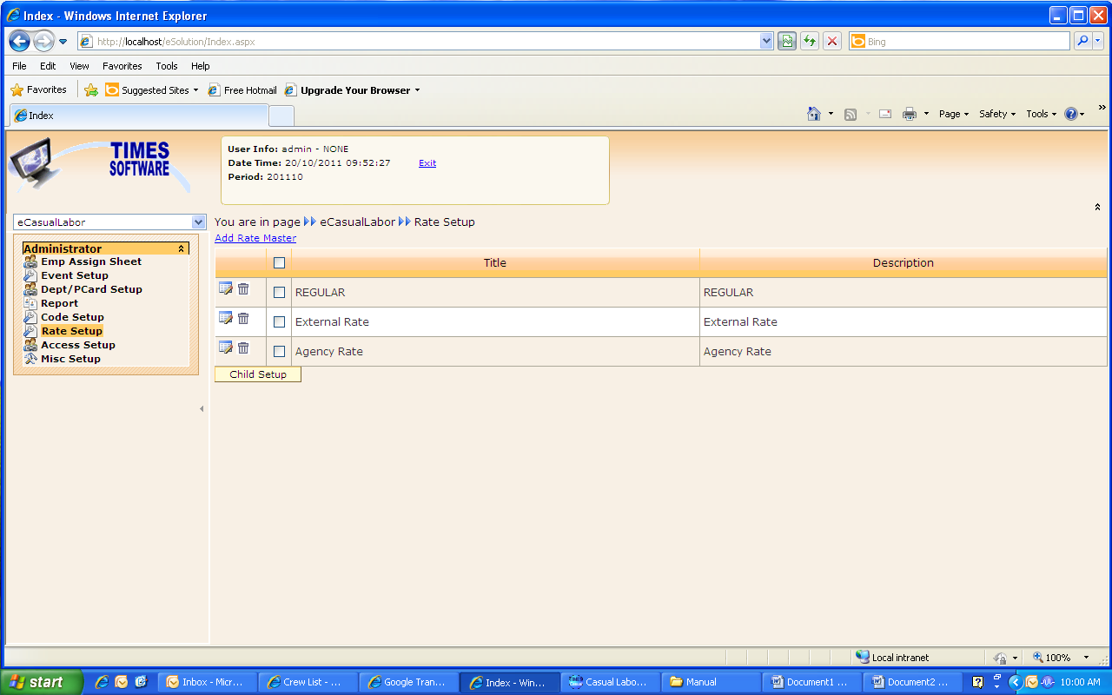

2.1 Click on the “Add Rate Master”, a screen will pop up to add new rate code.
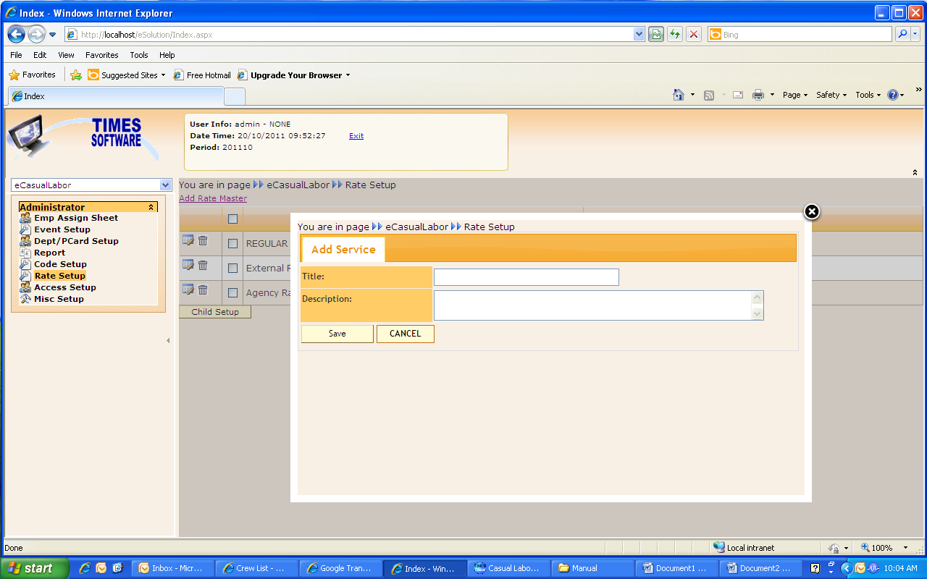
Title : Key in the Title for the new Rate Master
Description : Key in the description
Click “SAVE” to save the data or click “CANCEL” to cancel the data.

2.2 Select the rate by tick the check box and click on the “Child Setup” to set up the rate.
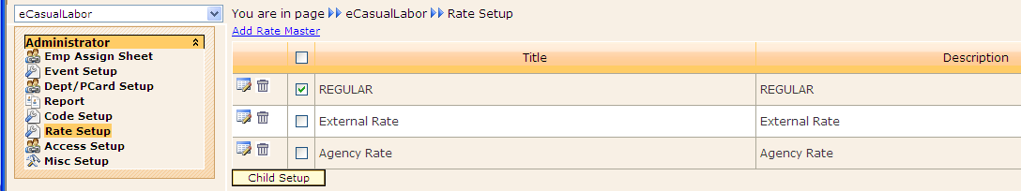

2.3 Click on “Add Rate Child” to add new rate.

2.4 You can click on 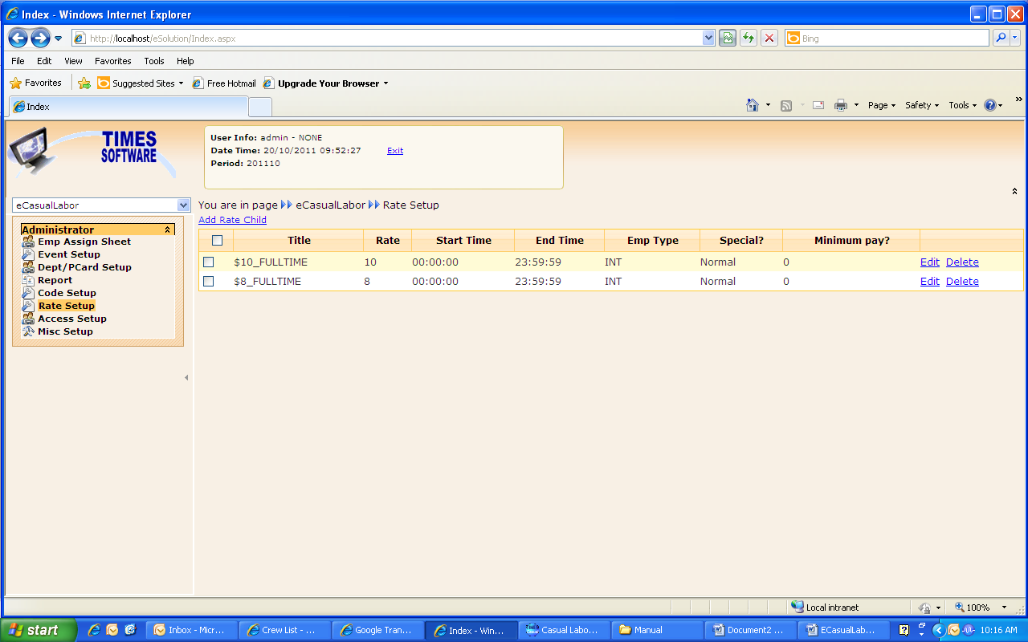to edit the existing record or to delete the record.

2.5 When you click “Add Rate Child”, a screen will appear as below. You can key in the data accordingly.
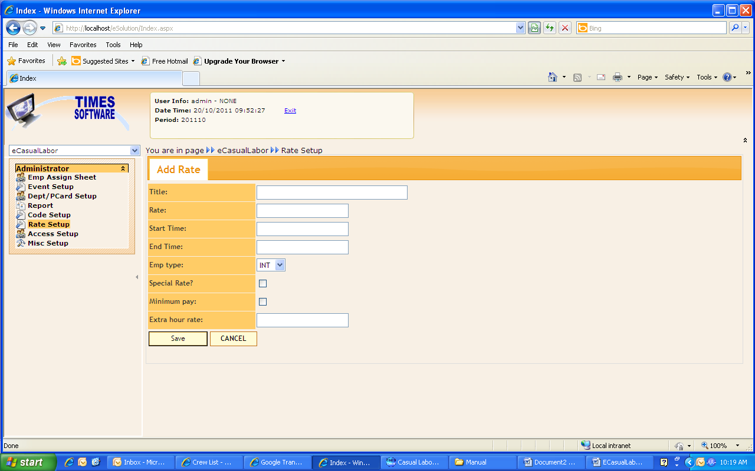
Title : Key in the Rate Child Title
Rate : Key in the Rate Amount
Start Time : Key in when the start time of the Rate Child
End Time : Key in when the end time of the rate child
Emp Type : Choose the Employee Type (INT for Full-time staff working as Casual Labour, EXT for Part Timer and AGY for Contractor)
Special Rate : Tick if the rate is special rate.
Click “SAVE” to save the data or click “CANCEL” to cancel the data.

Step 3: Access Code Setup
(Access Setup is to define approval flow for E-Casual Labor. The Approval Flow is by Cost Centre.)
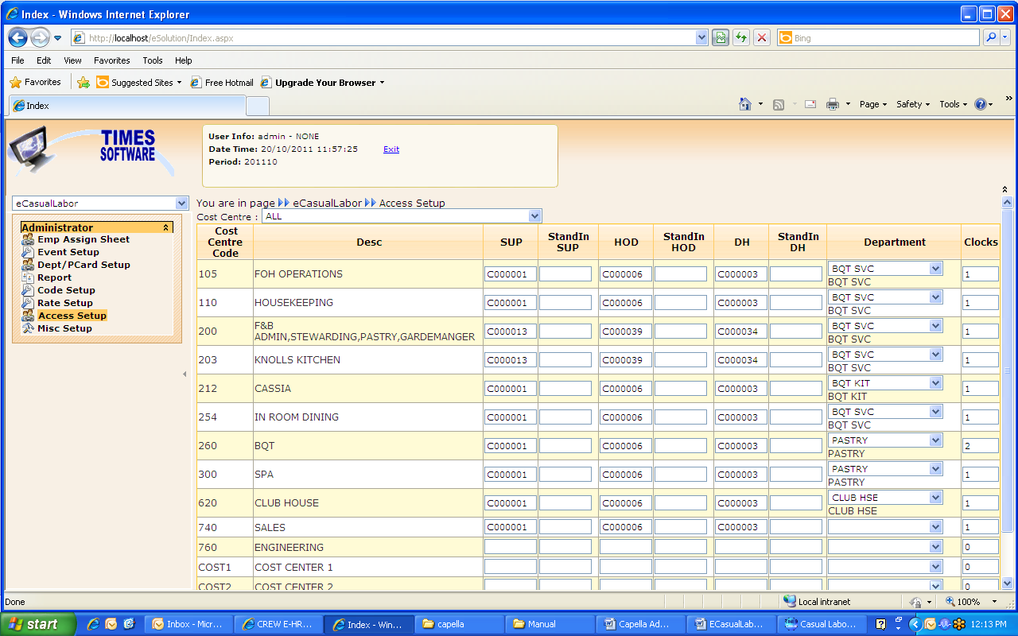

Code : Cost Cente Code
Desc : Cost Centre Description
SUP : Key in Employee Number for this Cost Centre Supervisor
Standin Sup : Key in Employee Number for this Cost Centre Stand In Supervisor
HOD : Key in Employee Number for this Cost Centre HOD (Head Of Department)
Standin HOD : Key in Employee Number for this Cost Centre Stand in HOD
DH : Key in Employee Number for this Cost Centre DH (Division Head)
Standin DH : Key in Employee Number for this Cost Centre Stand in DH
Department : Choose HOD (Head of Department)’s Department
Clocks : Type in the Clocks (2 : 2 times clock in and out, 1 : 1 time clock in and out )

Step 4: Dept / PCard Setup
(This setting is defining the rate table for the department)
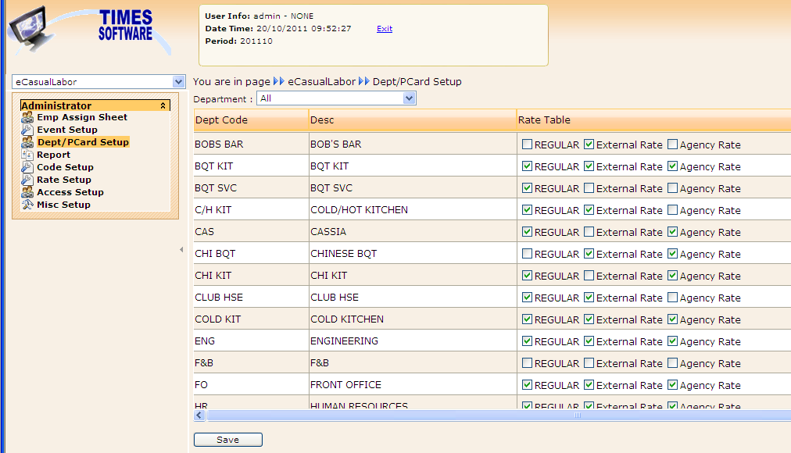
4.1 You can select the particular department by click on the drop down list to select the department code. By default system will display the entire department in the screen.

4.2 In the “Rate table” column, administrator has to define the rate for the particular department by tick the check box.

4.3 Click “SAVE” to save the data.

Step 5: Code Setup
(To setup the Location, Meal Hours deduction and Meal allowance)
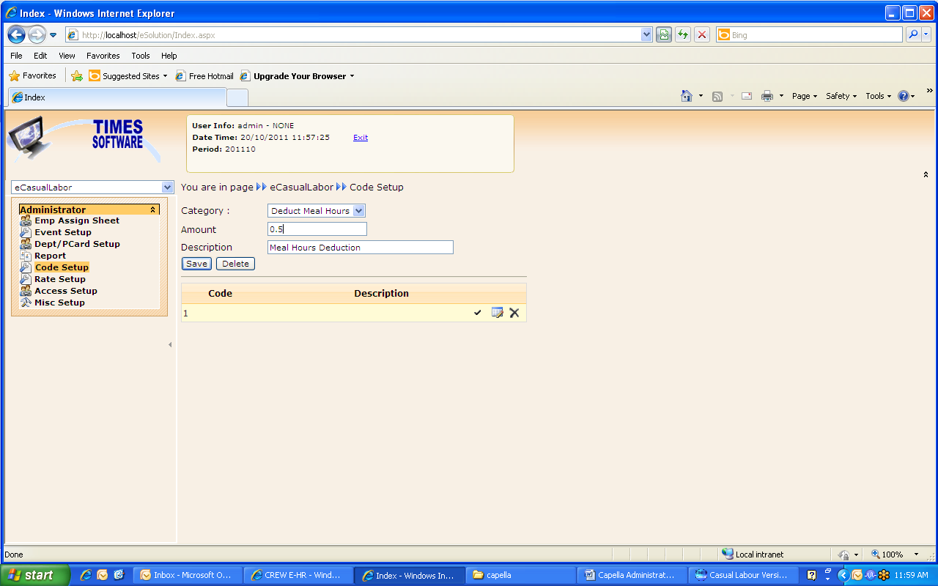
5.1 Category : Select the Category (e.g: Deduct Meal Hours)
Amount : key in the new hours for Meal deduction
(e.g: 0.5=30 min) Formula calculation is 30/60=0.5
Description : Key in the description

5.2 Click “SAVE” to save the data.

Administrator setup for Casual Labor system

Key in Employee Master File

Step 1: Login into Casual Labor system

Step 2: Go to Update Employee
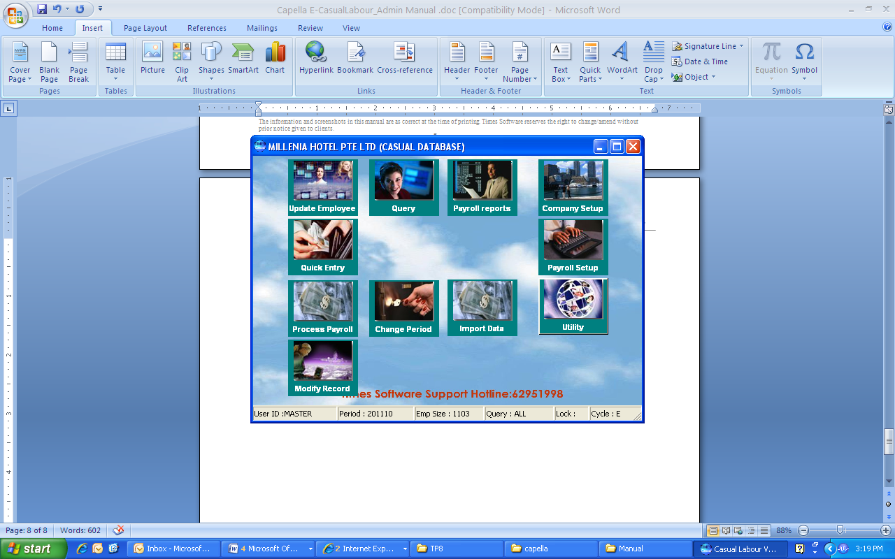

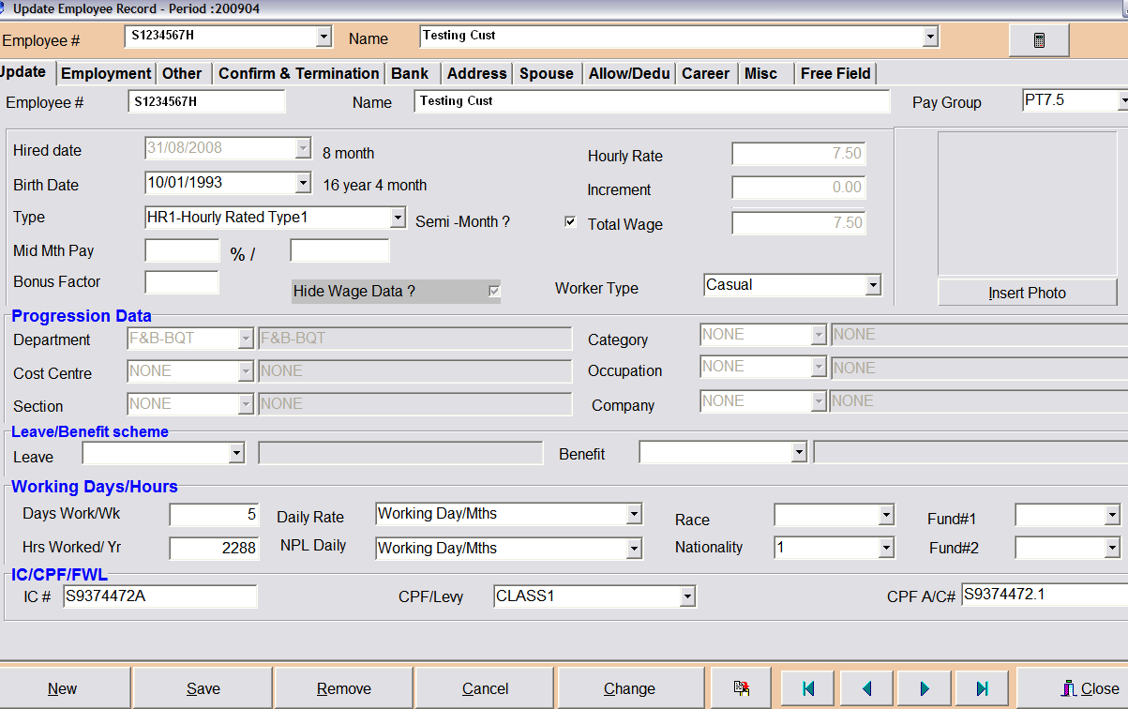

2.1. Click “New” button to key in new record

2.1.1. Key in employee No

2.1.2. Key in employee name

2.1.3. Key in hired data

2.1.4. Key in Birth Date

2.1.5. Employee type: choose “HR1”

2.1.6. Tick “Semi Month”

2.1.7. Select worker type.

2.1.8. Choose the “Department”

2.1.9. Choose the “Occupation”. This is compulsory for IR8A purpose.

2.1.10. Choose the “section”.

2.1.11. Choose the “race”.

2.1.12. Choose the employee “Nationality”

2.1.13. Choose the Fund.

2.1.14. Key in the employee IC Number for Singaporean/ PR or FIN number for foreign worker

2.1.15. Choose the ‘CPF/LEVY’.Class1 for Singaporean.PR is for PR.

2.1.16. CPF ACC No will auto generated by systems.

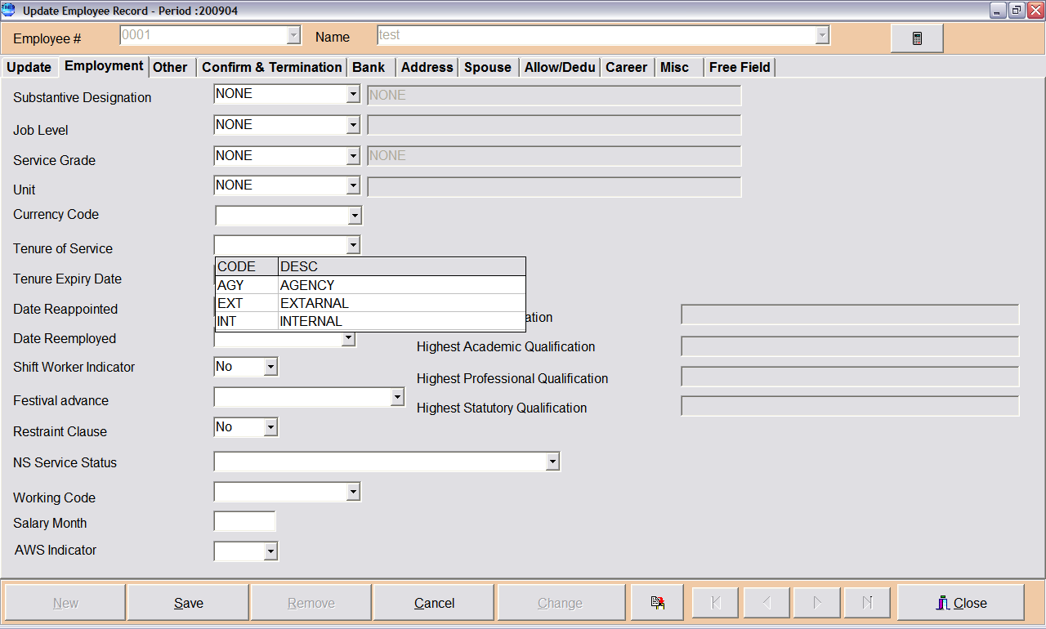

2.2. Go to “employment” tab
2.2.1. Choose the tenure of service.
INT - Full Timer work as part timer
EXT - Part Timer/casual
AGY - Contractor

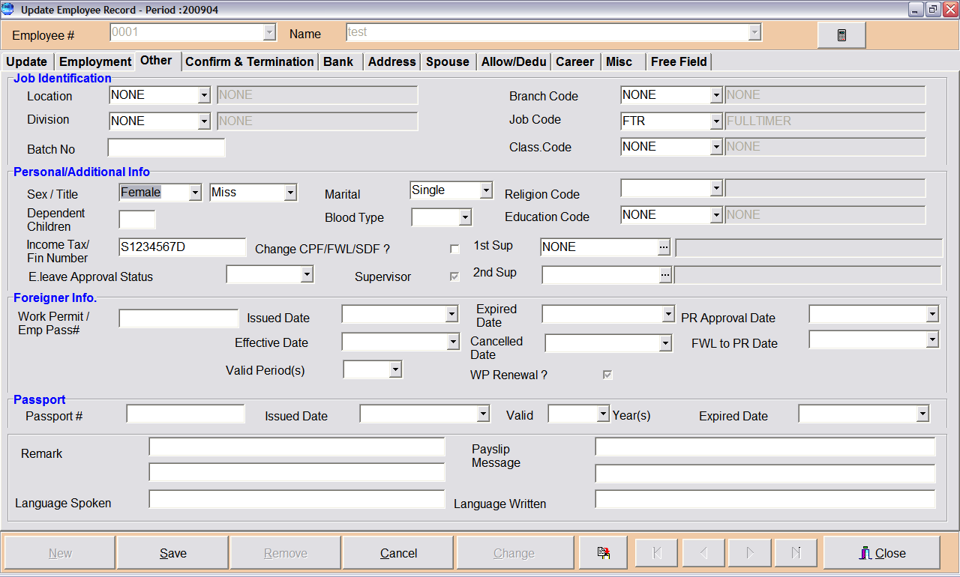
2.3. Go to “Other” tab
2.3.1. Choose the employee gender

2.3.2. This field is compulsory if the employee is foreign worker.
- work permit no: Key in work permit no
- Issued date: Key in the issued date of the pass
- Effective Date: Key in the effective date of the pass
- Expired Date: Key in the expired date of the pass
-Cancelled Date: if the pass already cancel, key in the cancelation date

2.3.3. For PR, this field is compulsory:
- PR Approval Date
- FWL to PR Date

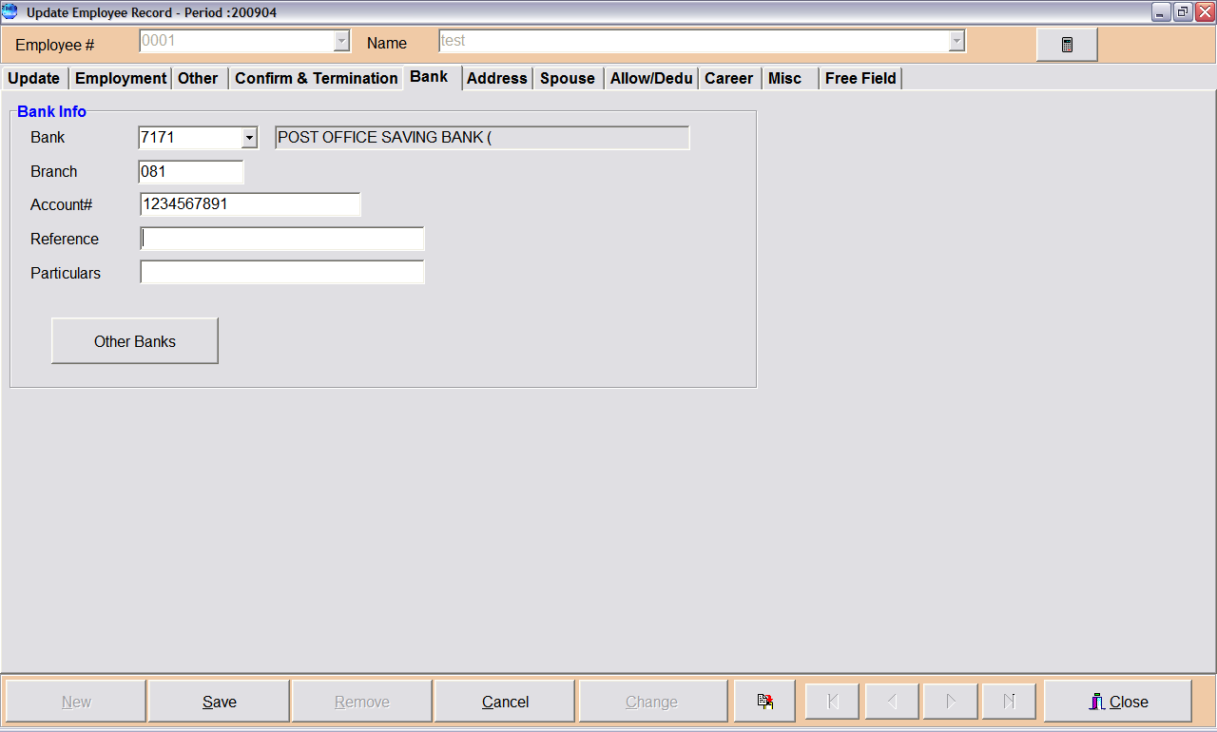
2.4. Go to ‘Bank” tab to key in employee bank.
2.4.1. Choose the Bank and bank account number.

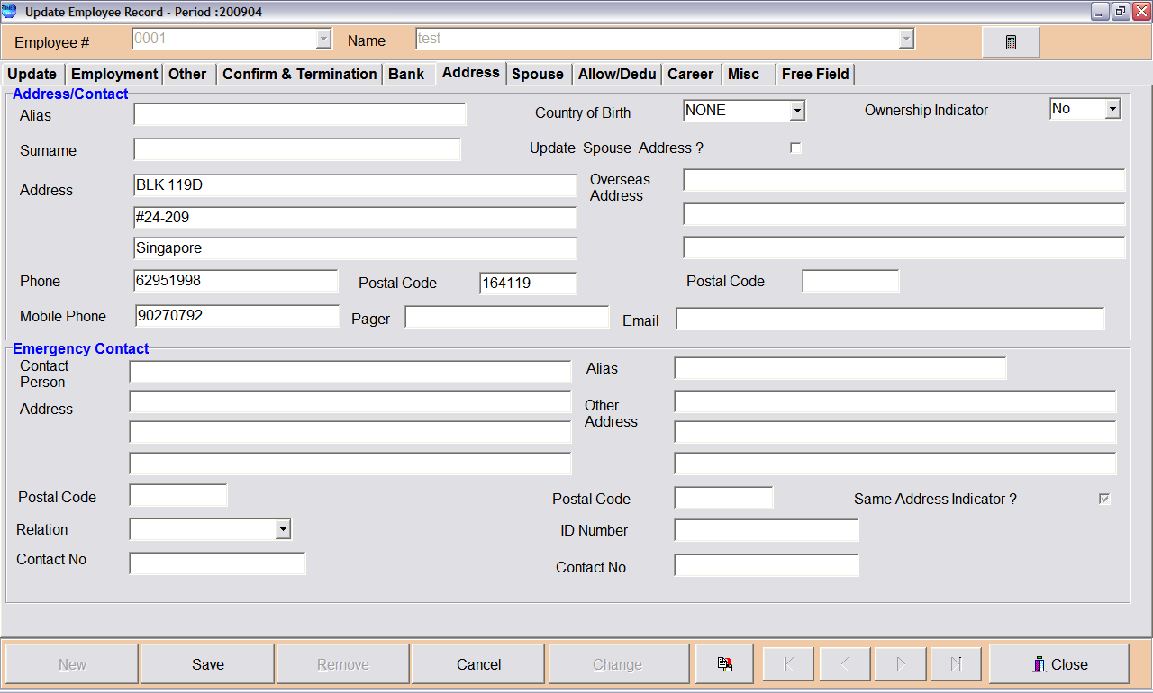
2.5. Go to “Address” tab.
2.5.1. Key in the employee address with 3 line format
2.5.2. Key in postal code
2.5.3. Key in Phone Number
2.5.4. Key in Mobile Number
2.5.5. Key in Employee Email (Note: for supervisor, HOD and DH must key in the email address)

Casual Labor Allowance Mapping Setup

Step 3: Go to Company Setup
3.1. Go to “Other” tab
3.1.1. Select Allowance code for “MEAL” and “MISC”

