(.net Version)



TIMES SOFTWARE PTE LTD
Company Registration Number: 199804415D
10 Jalan Besar #14-01 Sim Lim Tower
Singapore 208787
Tel: (65) 6295-1998 Fax: (65) 6295-0998
http://www.timesoftsg.com.sg

Contents | Page
1.0 Supervisors Guide for eCasual Labor System ------ | 3
1.1 Logging into the E-Casual Labor System ---------------------------------------------- | 3
1.2 Event Of The Day ------------------------------------------------------------------------ | 4
1.3 Event Setup -------------------------------------------------------------------------------- | 4
1.4 Emp Assign Sheet ------------------------------------------------------------------------- | 9
1.5 View History ------------------------------------------------------------------------------- | 12
1.6 Report------------ -------------------------------------------------------------------------- | 13
1.7 Change Password ------------------------------------------------------------------------- | 20

Supervisors Guide for E-Casual Labor System

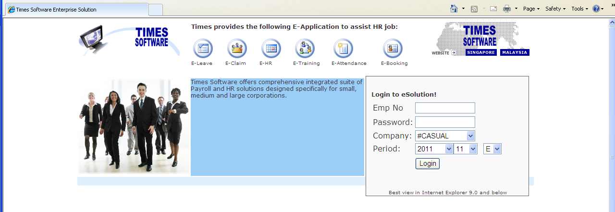

1.1 Logging into the E-Casual Labor System

At the Home Page of E-Casual Labor system: _
Step 1: Type Employee No. (Please check with your HR if you are unsure)
Step 2: Type Password (For 1st time using the software, it should be your NRIC No.eg. S1234567A)
Step 3: Select Company Name (By means of clicking the drop down list).
Step 4: Select Period (By means of clicking the drop down list).
Step 5: Click Login.

Note: Upon successful login, you will prompt to change your password for 1st time.
Minimum new password: 8 characters (Alphabet/Numeric)

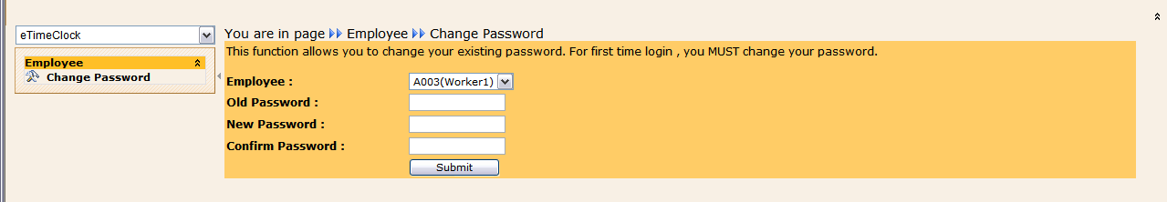

1.2 Event of the Day
Supervisor can view the event of the day by choosing the date 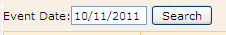and click 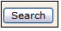

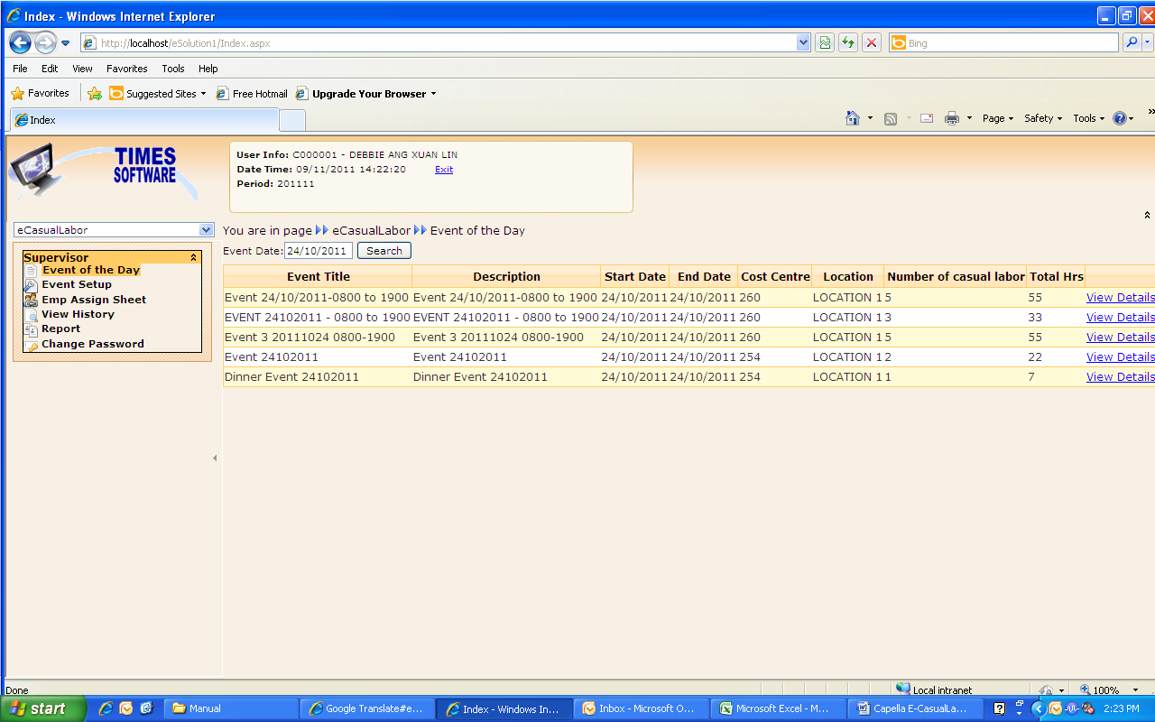
Click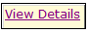to view the detail of the event.

1.3 Event Setup
Event Setup allow Supervisor to create new event, assign casual Labor for the event and can see all the list of the event.
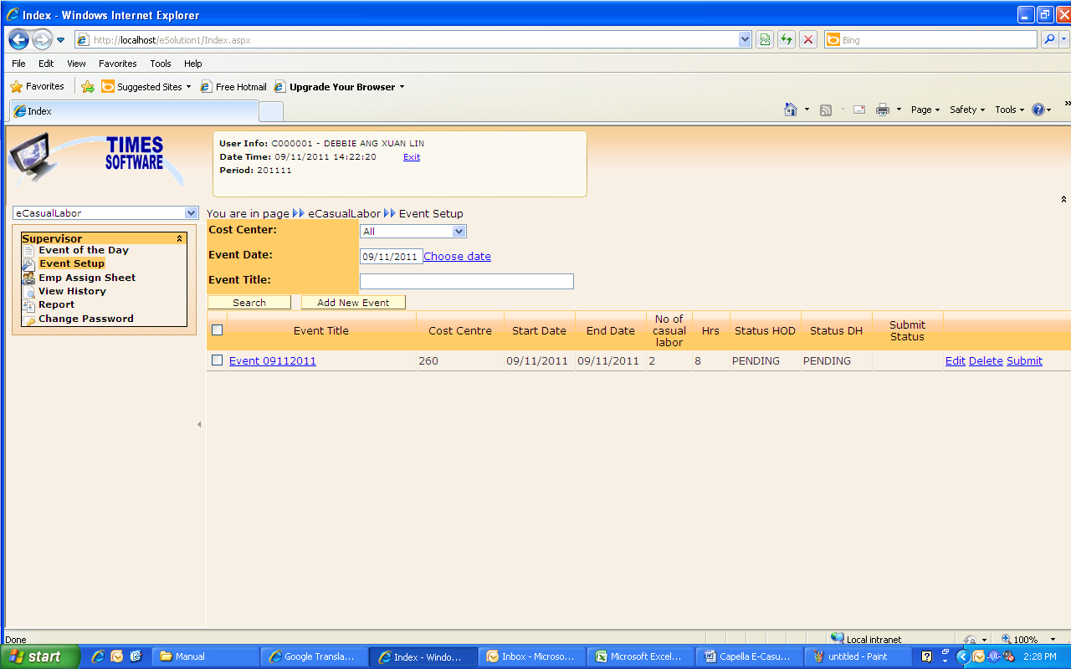

Supervisor is able to view the event based on Supervisor cost centre by clicking “Cost Center” drop down list
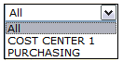

Supervisor is able to search the event date

Supervisor also is able to search the event based on event title:

Click “SEARCH” button to search the record
Create New Event
To create new event, just click 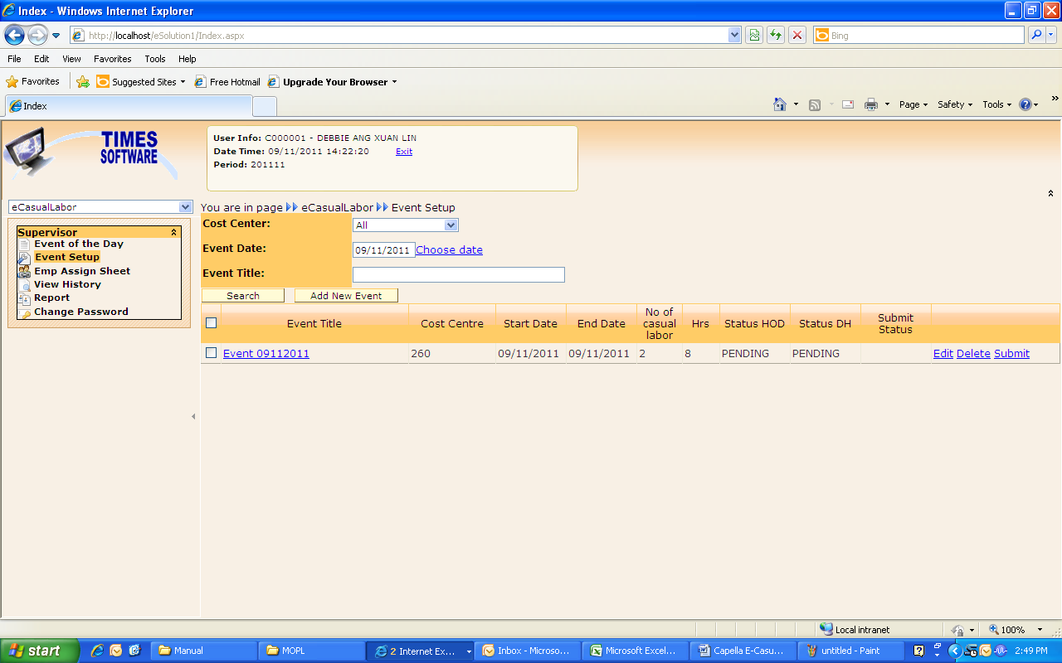

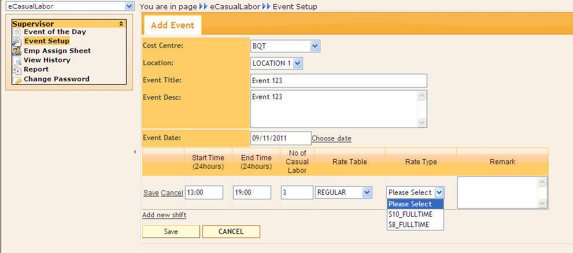

Cost Centre : Choose Cost Centre
Location : Choose Location
Event Title : Key in Event Title
Event Desc : Key in Event Description (compulsory)
Event Date : Key in date Event Date or by click on the choose date to select date
Start Time : Key in Event Start Time
End Time : Key in Event End Time
No Of Casual Labor : Key in No. of Casual Labor
Rate Table : Choose Rate Table
Rate Type : Choose Rate Type
External Rate type is applicable casual employee
Internal rate type is applicable for full time employees who are work as part timer.
Remark : Key in the remark (optional)

Click, to save the record
Click, to cancel the record
Click, if already key in the record
Click, if want to delete this record
Click to add new shift.

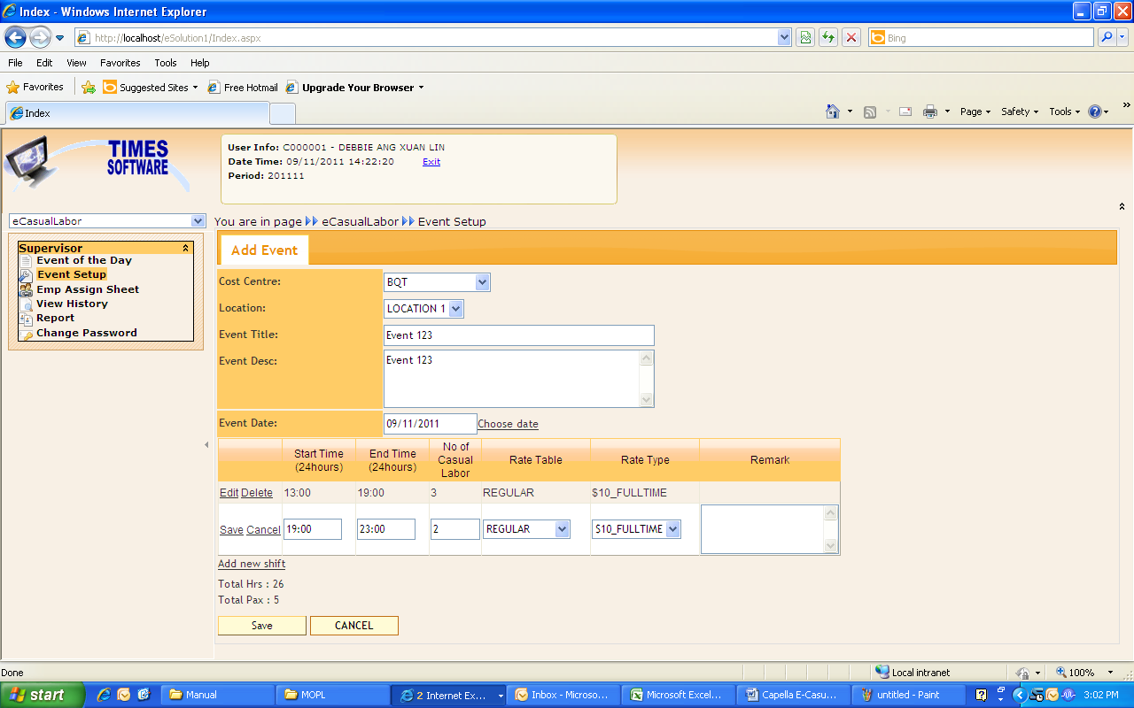

Click if done.

Once Supervisor created the event, need to get approval from HOD (Head of Department) and DH (Division Head).

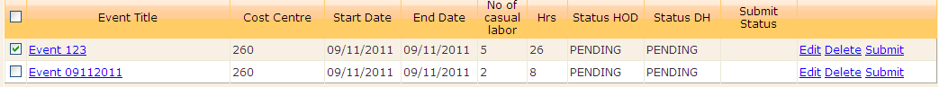
Tick the event  and click to get approval from HOD (Head of Department).

After click submit, status HOD (Head of Department) and DH (Division Head) will become “PENDING” and submit status become “SUBMITTED”

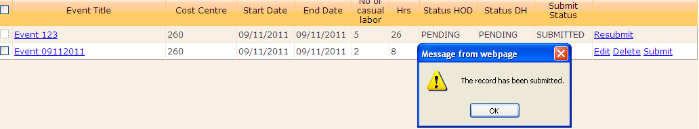

An email will send to HOD (Head of Department) to inform them for the event need for approval.
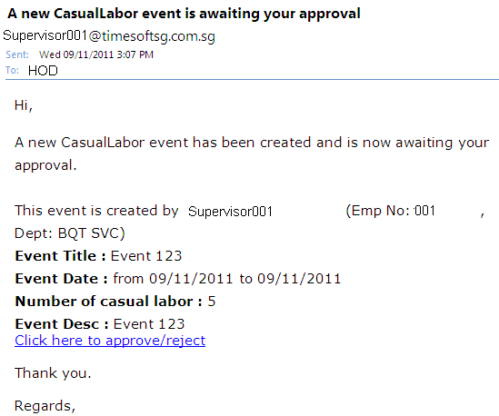
If HOD (Head of Department) rejects the event, status HOD (Head of Department) will become “REJECTED”

Supervisor can view HOD rejected reason.
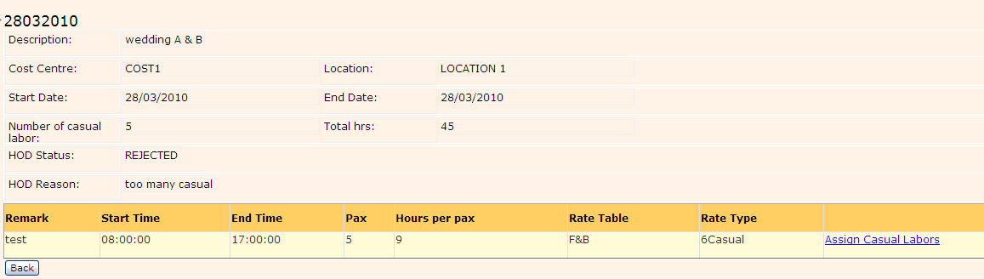

Supervisor can change the event detail by clicking “Edit”

After all the changes, Supervisor can resubmit the event to get approval from HOD.

Once HOD Approve the event, status HOD will become “APPROVED”

Same process with DH. And if DH has been approved the event will show as Approved Status.

Supervisor can proceed to assign Casual Labor If HOD and DH event status is “Approved”.
Click on the “event title”

Once “event title” clicked, Supervisor will be able to see below screen.
And click on “Assign Casual Labors” link
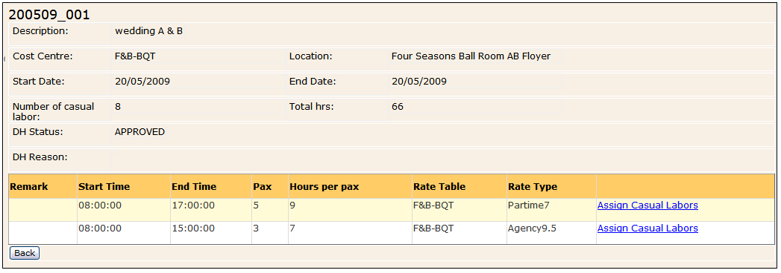

Once “Assign Casual Labors” clicked, Supervisor will be able to see below screen.
Click on “select casual labor”
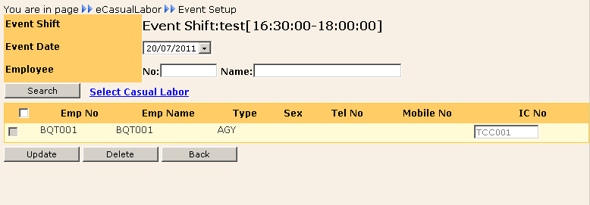

Supervisor must assign the employee based on rate type. Internal rate type for INT Emp Type and External Rate Type for EXT Emp Type.

Once “Save” button is clicked, supervisor will able to see below screen.
Right hand side table is the list of requested Employees.

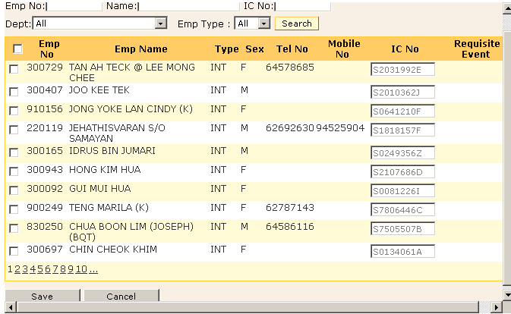

Sex : Casual Labor Gender
Tel No : Casual Labor Phone Number
Mobile No : Casual Labor Mobile Phone Number
IC NO : Casual Labor IC Number
Requisite Event : If there is timing in this column means the employee have been assign by another event with the same event date.

1.4 Emp Assign Sheet

Supervisor is able to view the entire record once casual Labor clock in at security.
Supervisor can do amendment for paid time in, paid time out, Deduct Meal Hours, and Misc Allowance.

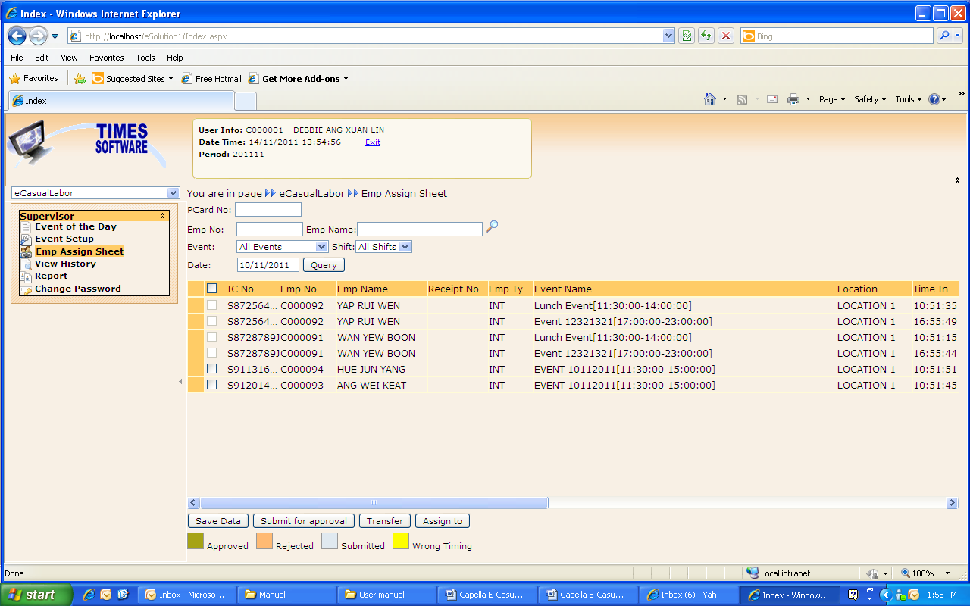

All field can be use to do the searching.
IC No : Search by IC No. Just type in the IC No and click “Query” button, it will show all the record for the IC No on that date.
Emp No : Search by Emp No. Just type in the Emp No and click “Query” button, it will show all the record for the Employee on that date.
Emp Name : Search by Emp Name. Just choose the Emp Name and click “Query” button, it will show all the record for the employee on that date.
Event : Allow SUPERVISOR (Head of Department) to view the record by event. Choose the event and click “Query” button, it will show all the record for the event on that date.
Shift : Allow SUPERVISOR (Head of Department) to view the record by Shift. Choose the shift and click “Query” button, it will show all the record for the event and shift on that date.
Date : Default will link to the computer date setting. If want to see another date record, just click the field, change date and click “Query” button.
Tick the record before do the changes.
Click in on the particular column to do the changes.
Don’t forget to click 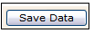after changes..
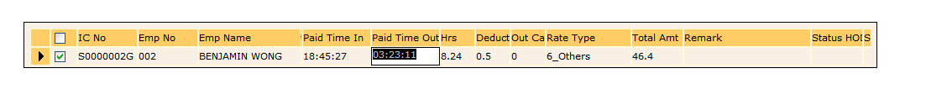
Tick the record before change the event.
Click 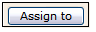button to change casual labor event.
Admin be able to see list of the event once button is clicked and admin can choose the new event.
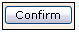: To confirm the event changes and click if done.
: To cancel the changes

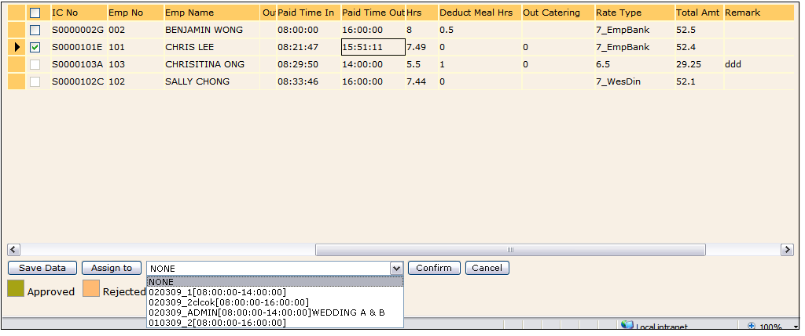

Submit Emp Assign Sheet For Approval.

To submit for approval supervisor need to Select the date, event and click “Query” Button.
Tick the record (a small box Beside “IC NO”), to get approval from HOD (Head of Department) and Division Head and click button.

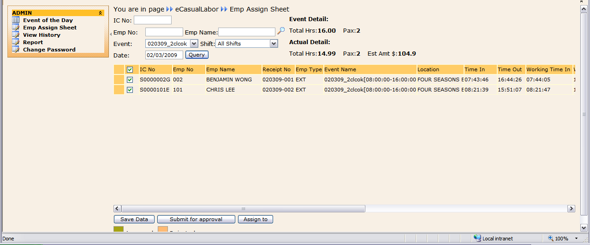

Once Supervisor Click button, the box of the record will highlight with gray color and Submit Status is “Submitted”
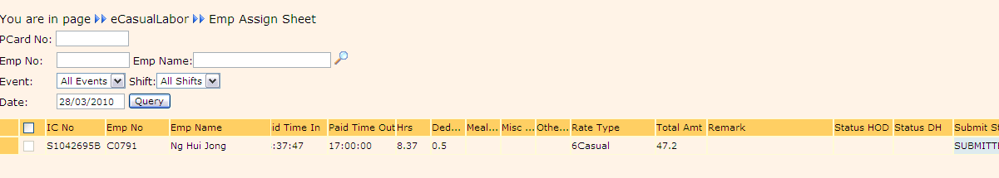

If HOD and DH have been approved the employee assign sheet, the Status will become “Approved”
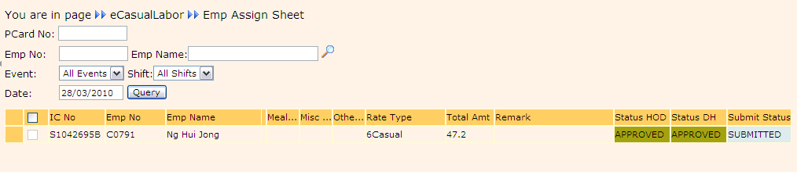

If HOD (Head of Department) rejected the record, the status HOD is “Rejected” and Supervisor can refer to Remark column to see HOD (Head of Department) reason for the rejecting. Supervisor can resubmit to get approval from HOD.

Same with DH, if DH rejected the record, the status DH is “Rejected” and Supervisor can refer to Remark column to see DH (Division Head) reason for the rejecting. Supervisor can resubmit to get approval from HOD and DH again.

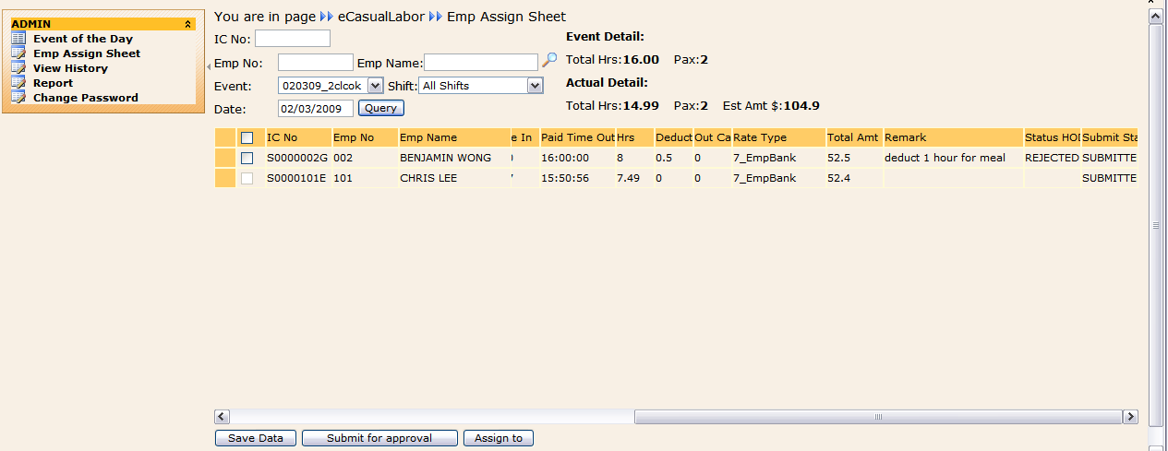

1.5 View History

Supervisor is able to view all the records of employee assign sheet in View History.This are just for viewing purpose.

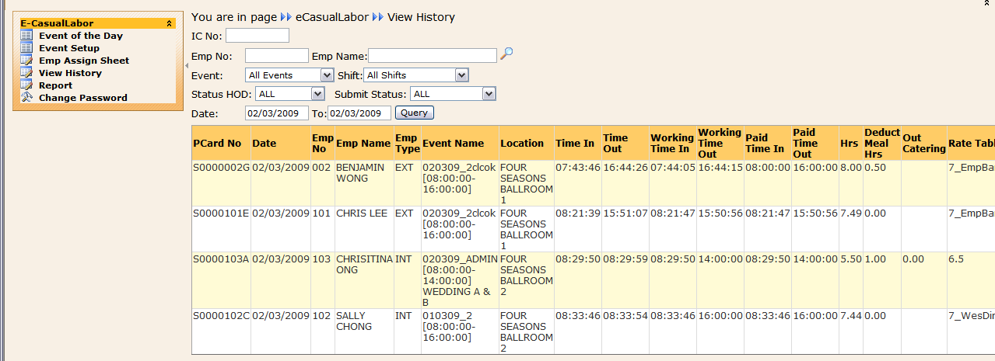

All field can be use to do the searching.
IC No : Search by IC No. Just type in the IC No and click “Query” button, it will show all the record for the IC No on that date.
Emp No : Search by Emp No. Just type in the Emp No and click “Query” button, it will show all the record for the Employee on that date.
Emp Name : Search by Emp Name. Just choose the Emp Name and click “Query” button, it will show all the record for the employee on that date.
Event : Allow Supervisor to view the record by event. Choose the event and click “Query” button, it will show all the record for the event on that date.
Shift : Allow Supervisor to view the record by Shift. Choose the shift and click “Query” button, it will show all the record for the event and shift on that date.
Status SUPERVISOR : Allow Supervisor to view the record by SUPERVISOR (Head Of Department) status. Choose the status and click “Query” button, it will show all the record for the event on that date.
Submit Status : Allow Supervisor to view the record by Submitted Status. Choose the Submit Status and click “Query” button, it will show all the record for the event on that date.
Date : Default will link to the computer date setting. If want to see another date record, just click the field, change date from and date to and click “Query” button.

1.6 Report
Supervisor be able to view some types of report.

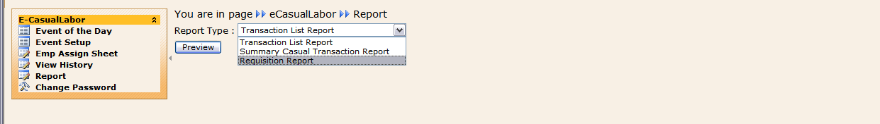

- Transaction List Report
This is list of transaction report. Click “Preview” button to preview the report.

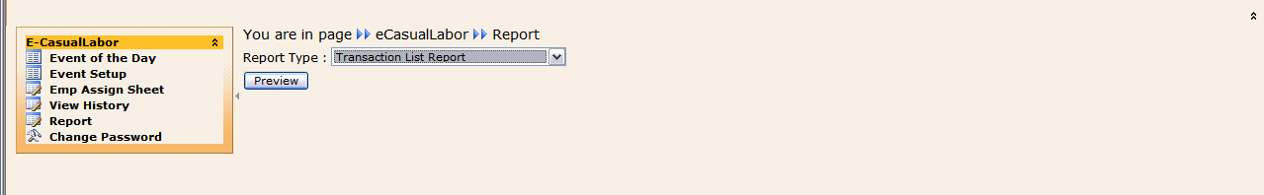

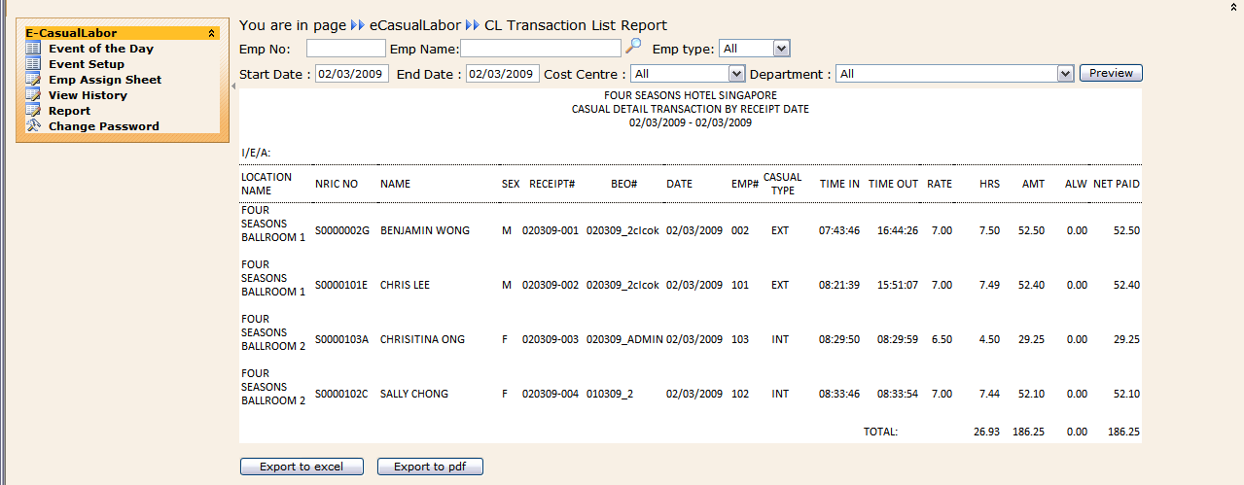

All field can be use to do the searching.

Emp No : Search by Emp No. Just type in the Emp No and click “Preview” button,it will show all the record for the Employee on that date.
Emp Name : Search by Emp Name. Just choose the Emp Name and click “Preview” button,it will show all the record for the employee on that date.
Emp Type : Allow Supervisor to view the record by Emp Type (Internal, External or Agency). Choose the Emp type and click “Preview” button.
Cost Centre : Allow Supervisor to view the record by Cost Centre. Choose the shift and click “Preview” button.
Department : Allow Supervisor to view the record by Department. Choose the status and click “Preview” button.
Start Date : Allow Supervisor to view the record by choosing the start date.
End Date : Allow Supervisor to view the record by choosing the End date.

Export to Excel
Supervisor is able to export the report to excel format.
Just click: 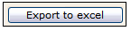
Click “Open” or “Save” Button and “Cancel” to Cancel.
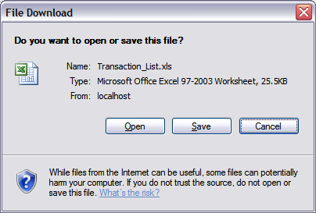

Click “Open”
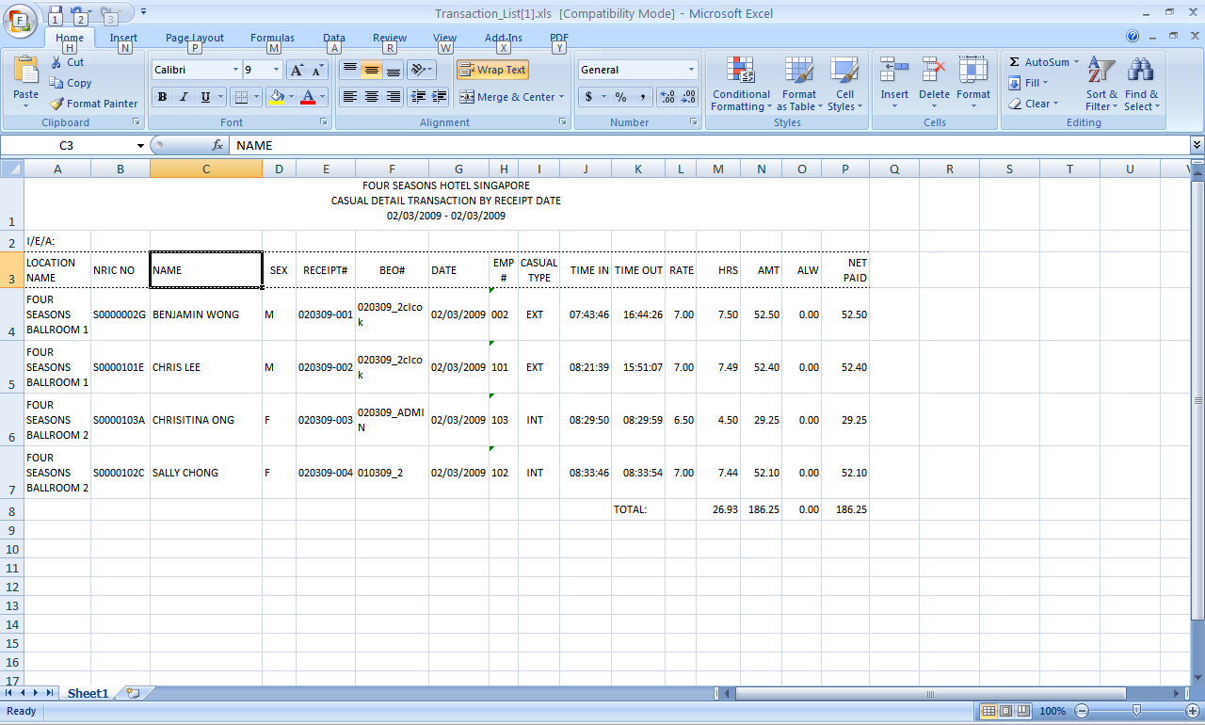

Click “Save”
Choose the directory to save the file.
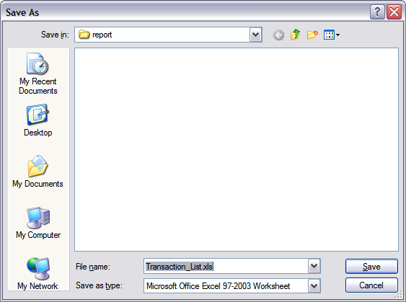

Export to Pdf
Supervisor be able to export the report to pdf format.
Just click: 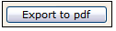
Click “Open” or “Save” Button and “Cancel” to Cancel.
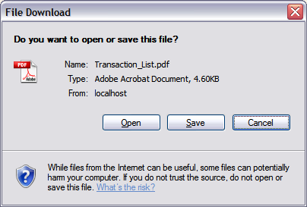

Click “Open”
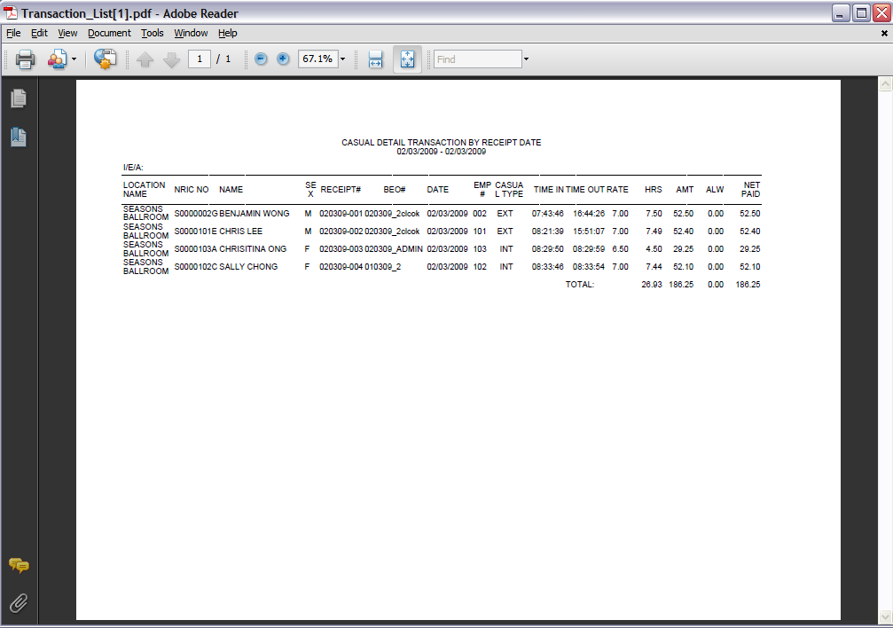
Click “Save”
Choose the directory to save the file.
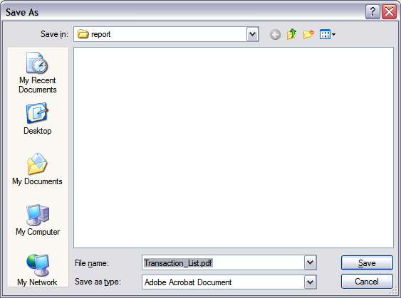

- Summary Casual Transaction Report
This is Summary Casual Report. Supervisor be able to view the report by Department, By Casual Labor or By event. Click “Preview” button to preview the report.

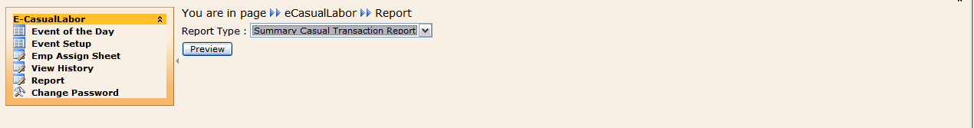

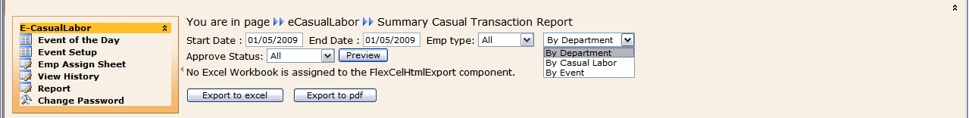

All field can be use to do the searching.

Emp Type : Allow Supervisor to view the record by Emp Type (Internal, External or Agency). Choose the Emp type and click “Preview” button.
Approve Status : Allow Supervisor to view the record by Approve Status. Choose the Approve Status and click “Preview” button.
Start Date : Allow Supervisor to view the record by choosing the start date.
End Date : Allow Supervisor to view the record by choosing the End date.

Summary Casual Transaction Report by Department
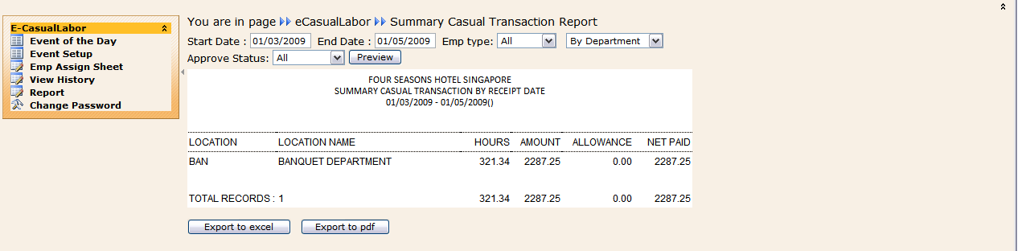

Summary Casual Transaction Report by Casual Labor
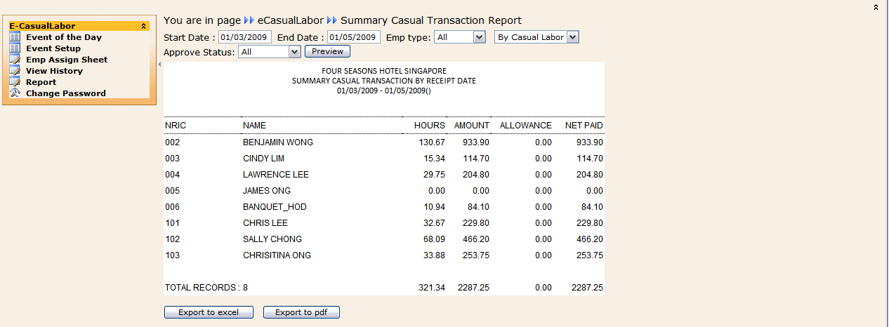

Summary Casual Transaction Report by Event
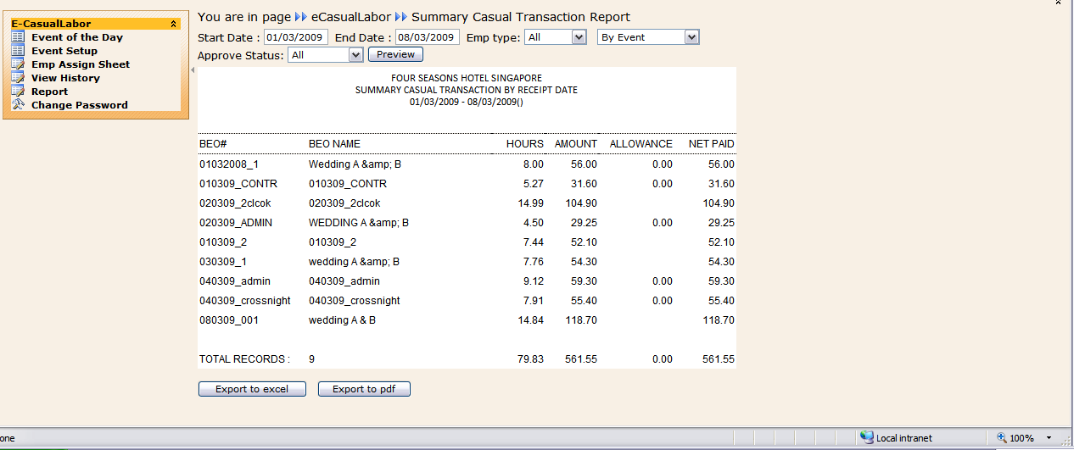

All of the report can export to excel and pdf format.
- Requisition Report
From this report Supervisor be able to view the requested Casual Labor.

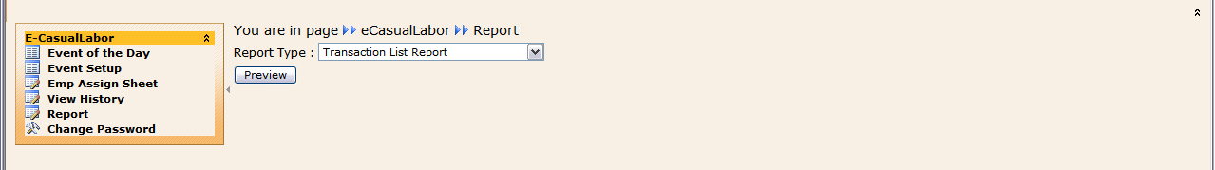

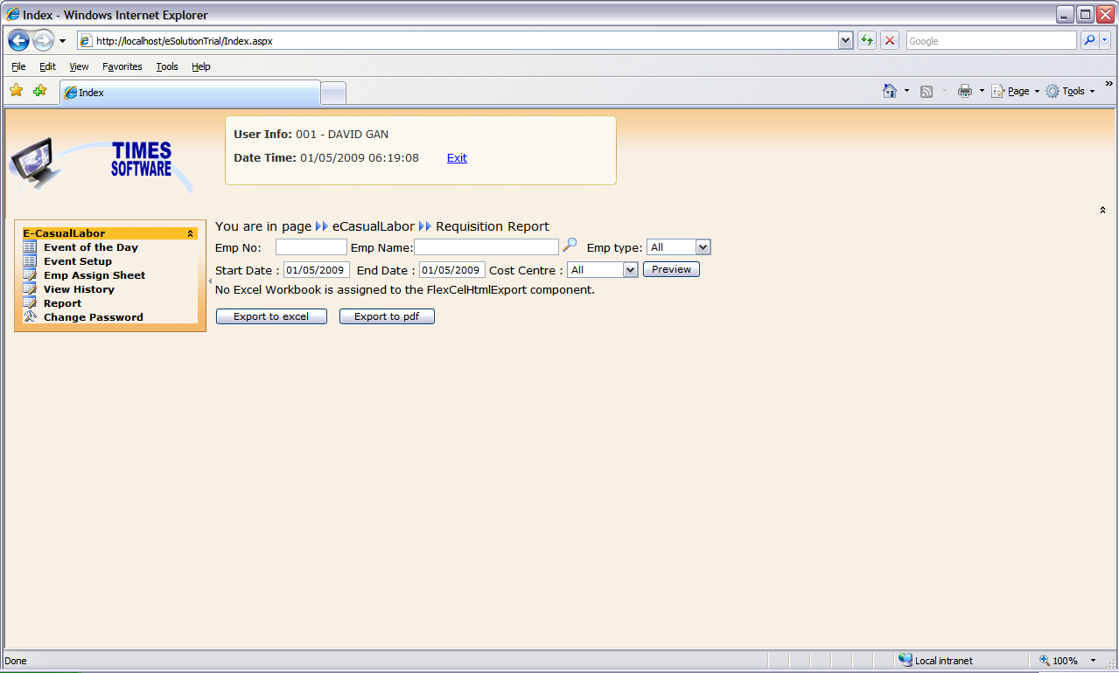

Emp No : Search by Emp No. Just type in the Emp No and click “Preview” button,it will show all the record for the Employee on that date.
Emp Name : Search by Emp Name. Just choose the Emp Name and click “Preview” button,it will show all the record for the employee on that date.
Emp Type : Allow Supervisor to view the record by Emp Type (Internal, External or Agency). Choose the Emp type and click “Preview” button.
Cost Centre : Allow Supervisor to view the record by Cost Centre. Choose the shift and click “Preview” button.
Start Date : Allow Supervisor to view the record by choosing the start date.
End Date : Allow Supervisor to view the record by choosing the End date

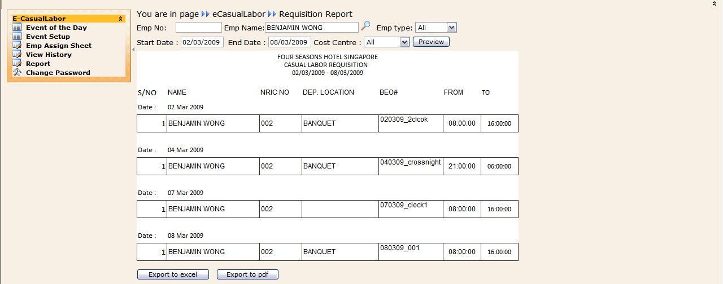

This report also is able to export to excel format or pdf format.

1.7 Change Password
Supervisor is able to change the password.
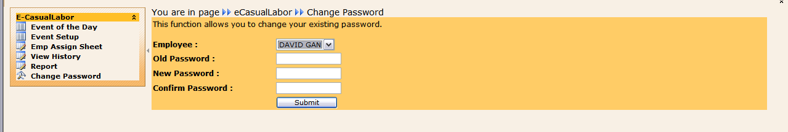

Old Password : Key in Old Password
New Password : Key In New Password
Confirm Password : Key In Confirm New Password

Click “Submit” button.

