- New Landing Page with announcement
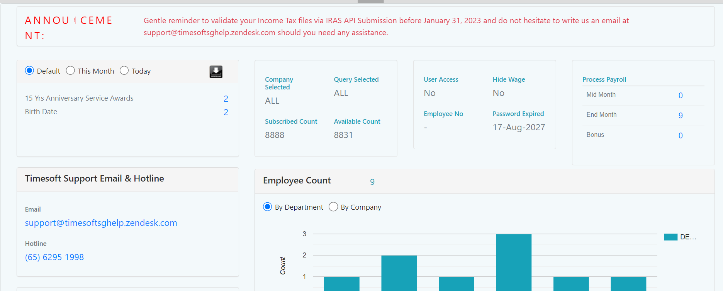

- Change of CPF rate for employees aged above 55 to 70 in 2023

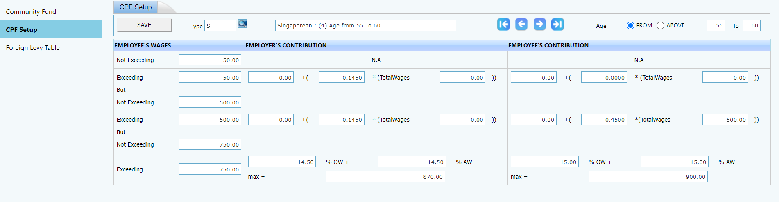

- New layout for IRAS submission page
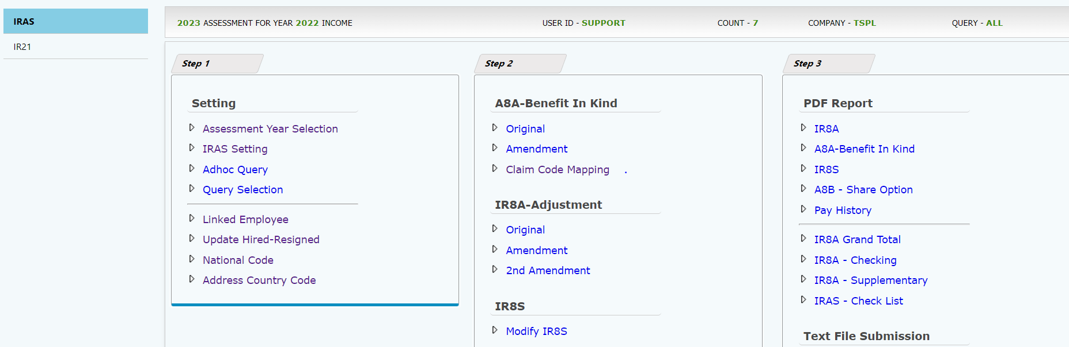

- Retirement age prompt
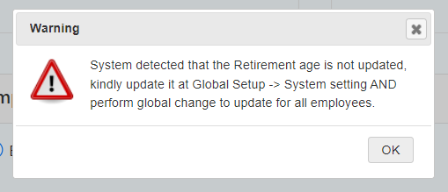

- Direct export excel from report writer
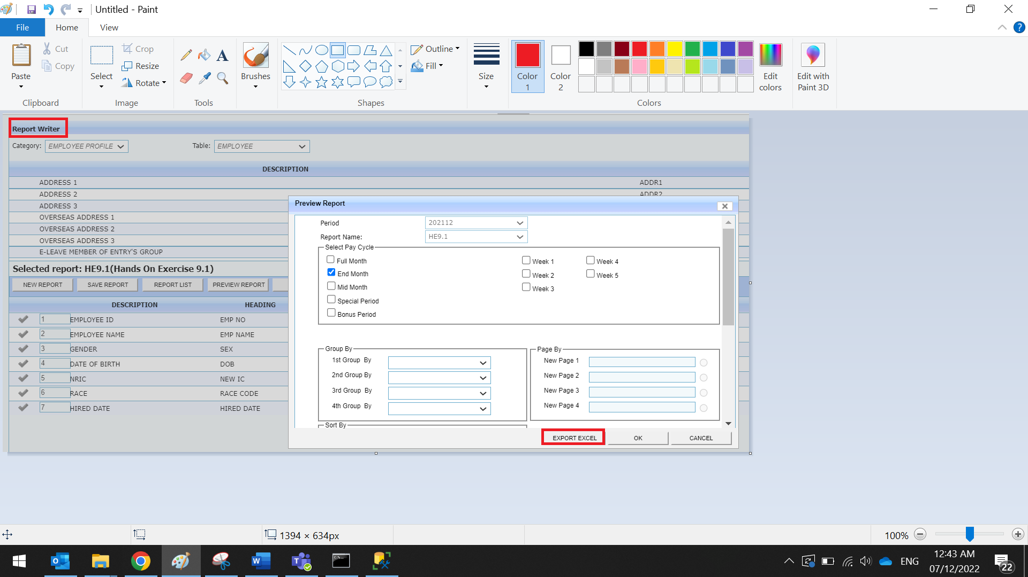

- Payroll processing for Resigned staff:
Error message prompt when there is pending leave/approved leave transaction for resigned staff
-Pending annual leave will affect leave encashment calculation
-Pending NPL will affect payroll deduction
-Approved annual leave/NPL after resignation date will impact payroll calculation.

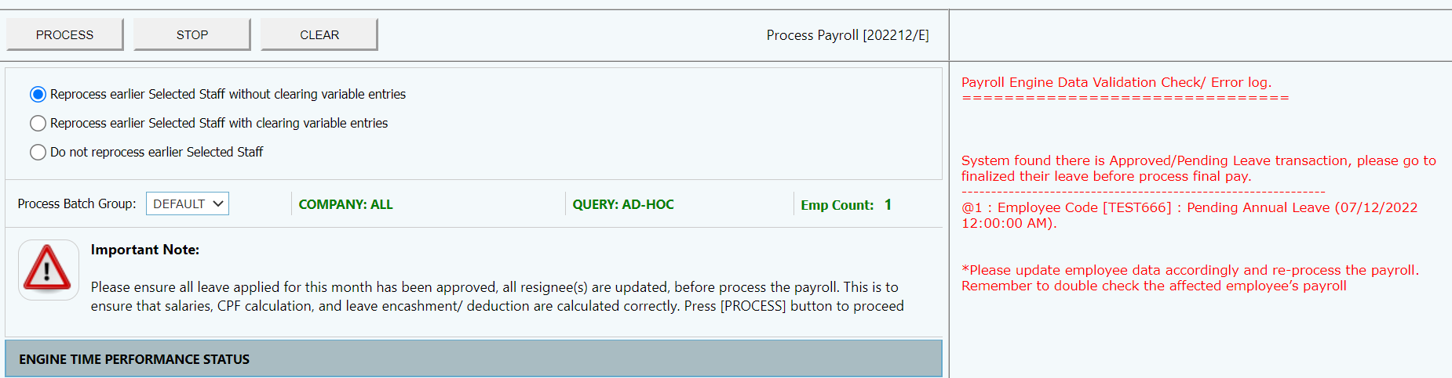

- New layout for Pay history report
